NORTHMINSTER UNITED CHURCH
300 Sunset Blvd., Peterborough ON K9H 5L3
Tel. 705-748-4881
www.northminsteruc.ca Email: info@northminsteruc.ca
Minister: Rev. Kevin Derry
Email: minister@northminsteruc.ca
Music Director: Dustin Bowers
Sunday, December 21, 2025 at 10 am
Advent IV Love
Music as We Gather
Welcome
Acknowledgement of the Land:
This morning, we gather as Northminster United Church and we acknowledge that we gather here on the traditional territories of the Mississauga Anishinaabe people. We give thanks for their care for the land over thousands of years and for their deep spirituality and honouring of the Creator and the creation. May we live with respect in God's creation and in harmony with our neighbours.
Life, and Work of the Community
Music as We Centre
Lighting the Advent Wreath: ” Love”
Led by Lynn Bartholomew
One: The Advent Season is a time known for candles, coloured
lights, and bright stars.
All: This four-week long season points us towards the
cradle of Bethlehem and the cross of Calvary.
One: It is important we light the candles to remind us that we
do not live in the shadows of despair and discouragement.
All: We are a people of light and love.
One: Today we light the candle of love to guide us on our
journey to Bethlehem… (the 4th purple candle is lit)
Let us sing together VU 7 “Hope is a Star”
1 Hope is a star that shines in the night,
leading us on till the morning is bright.
R When God is a child there's joy in our song.
The last shall be first and the weak shall be strong,
and none shall be afraid.

2 Peace is a ribbon that circles the earth,
giving a promise of safety and worth. R

3 Joy is a song that welcomes the dawn,
telling the world that the Saviour is born. R

4 Love is a flame that burns in our heart,
Jesus has come and will never depart. R †
Opening Prayer
Words of Assurance:
One: The Advent candles illuminate our journey to Bethlehem.
All: Through reflection, transformation, and action this
Advent Season we, once again, journey to Bethlehem seeking the intimate presence of the Holy.
Hymn: VU46 “Gentle Mary Laid Her Child”
1 Gentle Mary laid her child lowly in a manger;
there he lay, the undefiled, to the world a stranger.
Such a babe in such a place, can he be the Saviour?
Ask the saved of all the race who have found his favour.

2 Angels sang about his birth, wise men sought
and found him;
heaven's star shone brightly forth, glory all around him.
Shepherds saw the wondrous sight,
heard the angels singing;
all the plains were lit that night, all the hills were ringing.

3 Gentle Mary laid her child lowly in a manger;
he is still the undefiled, but no more a stranger.
Son of God of humble birth, beautiful the story;
praise his name in all the earth; hail the King of glory! †
First Lesson: Isaiah 7:10-16 Lynn Bartholomew
^{7:10} Again the Lord spoke to Ahaz, saying, ¹¹ Ask a sign of the Lord your God; let it be deep as Sheol or high as heaven. ¹² But Ahaz said, I will not ask, and I will not put the Lord to the test. ¹³ Then Isaiah said: ‘Hear then, O house of David! Is it too little for you to weary mortals, that you weary my God also? ¹⁴ Therefore the Lord himself will give you a sign. Look, the young woman is with child and shall bear a son, and shall name him Immanuel. ¹⁵ He shall eat curds and honey by the time he knows how to refuse the evil and choose the good. ¹⁶ For before the child knows how to refuse the evil and choose the good, the land before whose two kings you are in dread will be deserted.
Psalm Selection: VU794, Part 1 (from Psalm 80)
Led by Lynn Bartholomew
Refrain: Your face, God, shine on us and give us peace.
Part One (1-7, 18-19)
One Shepherd of Israel, hear us,
All you who lead Joseph like a flock,
you who are enthroned amidst the cherubim.
One Shine forth before Ephraim, Benjamin and Manasseh;
All stir up your might, come and save us. R

One God of hosts,
how long will you be angry with your people's prayer?
All You have fed us with the bread of weeping,
and given us tears in plenty to drink.
One You have made a mockery of us to our neighbours,
All and our enemies laugh us to scorn.
One Let your hand rest on the one at your right hand,
on the one you have made strong for yourself.
All Then we will never forsake you;
give us life, and we will call on your name. R
Hymn: VU62 “Once in Royal David’s City”
1 Once in royal David's city
stood a lowly cattleshed,
where a mother laid her baby
in a manger for his bed.
Mary was that mother mild,
Jesus Christ her little child.

2 He came down to earth from heaven
who, with God, is over all,
and his shelter was a stable,
and his cradle was a stall.
There among the poor and lowly
lived on earth our Saviour holy.

3 For he is our lifelong pattern;
daily, when on earth he grew,
he was tempted, scorned, rejected,
tears and smiles like us he knew.
Thus he feels for all our sadness,
and he shares in all our gladness.

4 And our eyes at last shall see him,
through his own redeeming love;
for that child who seemed so helpless
is our Lord in heaven above;
and he leads his children on
to the place where he is gone. †
Young at Heart Time: “A Place in the Story”
Gospel Lesson: Matthew 1:18-25 Lynn Bartholomew
^{1:18} Now the birth of Jesus the Messiah took place in this way. When his mother Mary had been engaged to Joseph, but before they lived together, she was found to be with child from the Holy Spirit. ¹⁹ Her husband Joseph, being a righteous man and unwilling to expose her to public disgrace, planned to dismiss her quietly. ²⁰ But just when he had resolved to do this, an angel of the Lord appeared to him in a dream and said, ‘Joseph, son of David, do not be afraid to take Mary as your wife, for the child conceived in her is from the Holy Spirit. ²¹ She will bear a son, and you are to name him Jesus, for he will save his people from their sins.’ ²² All this took place to fulfil what had been spoken by the Lord through the prophet:
²³ ‘Look, the virgin shall conceive and bear a son,
and they shall name him Emmanuel’,
which means, ‘God is with us.’ ²⁴ When Joseph awoke from sleep, he did as the angel of the Lord commanded him; he took her as his wife, ²⁵ but had no marital relations with her until she had borne a son; and he named him Jesus.

Response
Reader: As we listen to the words from our scripture...
All: may we hear the stories from our faith history that
inspire us to embrace the promise and new life shared with us by the Advent Spirit of the Holy.
Reader: In the name of Jesus, the Christ, Emmanuel, God-with-
us...
All: Amen.
Meditation: “A Forgotten Figure”
Music for Meditation
Please stand for The New Creed
The New Creed VU918
One: Let us join together in a statement of our communal
faith…
All: We are not alone,
we live in God’s world.
We believe in God:
who has created and is creating,
who has come in Jesus,
the Word made flesh,
to reconcile and make new,
who works in us and others
by the Spirit.
We trust in God.
We are called to be the Church:
to celebrate God’s presence,
to live with respect in Creation,
to love and serve others,
to seek justice and resist evil,
to proclaim Jesus, crucified and risen,
our judge and our hope.
In life, in death, in life beyond death,
God is with us.
We are not alone.
Thanks be to God. Amen. †
Offertory
Doxology: VU540 “Grant Us, God, the Grace of Giving”
Grant us, God, the grace of giving,
with a spirit large and free,
that ourselves and all our living
we may offer faithfully. †
Dedication of Our Gifts
Hymn: VU64 “O Little Town of Bethlehem”
1 O little town of Bethlehem,
how still we see thee lie!
Above thy deep and dreamless sleep
the silent stars go by;
yet in thy dark streets shineth
the everlasting light;
the hopes and fears of all the years
are met in thee tonight.

2 For Christ is born of Mary;
and gathered all above,
while mortals sleep, the angels keep
their watch of wondering love.
O morning stars, together
proclaim the holy birth,
and praises sing to God the King,
and peace to all on earth.

3 How silently, how silently
the wondrous gift is given!
So God imparts to human hearts
the blessed gift of heaven.
No ear may hear his coming;
but in this world of sin,
where meek souls will receive him, still
the dear Christ enters in.

4 O holy child of Bethlehem,
descend to us, we pray;
cast out our sin, and enter in;
be born in us today.
We hear the Christmas angels
the great glad tidings tell;
O come to us, abide with us,
our Lord Emmanuel. †

Prayers of the People and the Jesus Prayer: A Paraphrase
All Eternal Spirit,
Earth-maker, Pain-bearer, Life-giver,
Source of all that is and that shall be.
Father and Mother of us all,
Loving God, in whom is heaven:
The hallowing of your name echo
through the universe!
The way of your justice be followed
by peoples of the world!
Your heavenly will be done
by all created beings!
Your commonwealth of peace and freedom
sustain our hope and come on earth.
With the bread we need for today, feed us.
In the hurts we absorb from one another, forgive us.
In times of temptation and test, strengthen us.
From trials too great to endure, spare us.
From the grip of all that is evil, free us.
For you reign in the glory of the power that is love,
now and for ever. Amen. Voices United 916
Please stand for the Closing Hymn
Closing Hymn: VU43 “Go, Tell It on the Mountain”
R Go, tell it on the mountain,
over the hills and everywhere.
Go, tell it on the mountain
that Jesus Christ is born.

1 While shepherds kept their watching
o'er silent flocks by night,
behold, throughout the heavens
there shone a holy light. R

2 The shepherds feared and trembled
when lo, above the earth
rang out the angel chorus
that hailed our Saviour's birth! R

3 Down in a lonely manger
the humble Christ was born,

and God sent our salvation
that blessed Christmas morn. R †
Blessing as We Go Forth:
One: Let us go from this place with the guiding lights of hope,
peace, joy and love.
All: Let us go from this place making the journey toward
the cradle in Bethlehem.
One: May we find there, once again, the intimate presence of
the Holy.
All: Let us go from this place sharing the Presence of
Emmanuel, God-with-us. Amen.
Sung Blessing: VU962 “May the Blessing of God”
May the blessing of God go before you.
May her grace and peace abound.
May her Spirit live within you.
May her love wrap you ‘round.
May her blessing remain with you always.
May you walk on holy ground. †
Music as the Worship Service Concludes
East Central Ontario Regional Council
Prayer Cycle
As church, we are called to pray for each other and for our mission in the world for the week of December 21, 2025
Emmanuel United Church, Foxboro
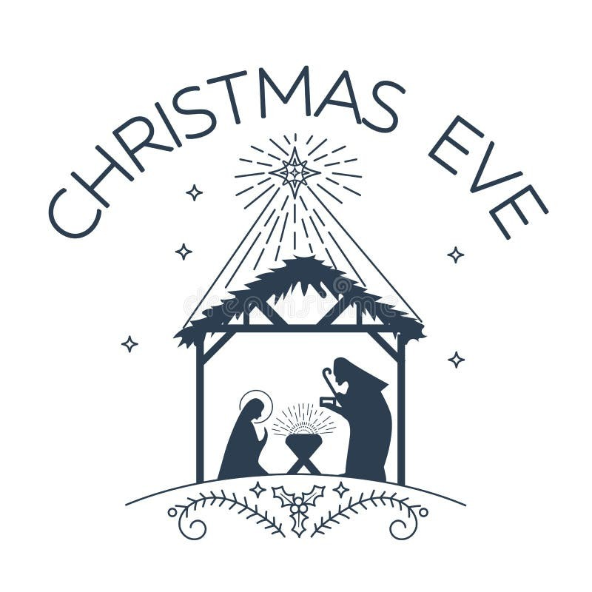
Service
Wednesday, December 24th at 7:30 p.m.
Thank You to This Week’s Volunteers for December 21, 2025
Duty |  | Nelson Pickett
Elevator |  | Carrie Varga
Greeters |  | Gord & Olivia James  Ann Thomas
Scripture Reader |  | Lynn Bartholomew
Congregational Elder |  | Carol Murduff
Sunday School Coordinator |  | Maggie Crawford
Sound |  | Gale Osmond
Video |  | Nelson Pickett
Videographer  Fellowship |  | Kathy Common  Affirm Committee
JOIN US FOR COFFEE TIME each Tuesday morning at 10 am. at Northminster United Church in Upper Wright Hall for a warm cup of coffee or tea and possibly a little snack. Bring a friend!!
Last coffee time of 2025 is December 16th & restart on January 6, 2026.

FOOD BANK SUNDAY- is held on the 2nd Sunday of each month. We invite you to bring items to support Kawartha Food Share. Boxes are located in the Sanctuary and at back foyer [exit to parking lot]. If you wish to make a cash donation instead, please make your cheque payable to: “Northminster United Church”. This can be placed on the offering plate. We also accept eTransfers to: treasurernuc@gmail.com

SUNDAY COFFEE VOLUNTEERS NEEDED if you are available the odd Sunday to help out Sunday mornings making coffee/tea, please let us know. There is a sign up sheet on the bulletin board in the
hallway beside Rev Kevin’s office. Thank you!
NEW MEMBER SUNDAY, Sunday, January 11, 2026. Anyone wishing to be a member of Northminster United Church, please let Rev Kevin or Michele in the office know.
OFFERING ENVELOPES … please contact Michele in the office to let her know you require offering envelopes. Email: info@northminsteruc.ca or Tel. # 705-748-4881.

The “Mitten Tree” continues to be decorated with mitten, scarves, hats, underwear & socks. All items will be donated to those in need. Please consider making a donation to our tree and help make someone’s Christmas a bit brighter…. This will be your last chance!
Donations can be made throughout Advent season.
PASTORAL CARE: If you know someone that is in the hospital that we should know about, please call the office and let us know. The hospital does not notify us & there is no longer access to a church list. If calling the church after hours, please leave a message 705-748-4881.
Please keep in mind, we all need to take care of each other.
WEEKLY ANNOUNCEMENTS If you are not on our weekly email list and would like to be, please let us know by sending us an email to: info@northminsteruc.ca

WE NEED YOUR HELP:
Join our Church Maintenance Team!….to ensure our church remains a safe, welcoming, and high-value space for our community. **No monthly meetings are required. **
Please speak with Rick Peconi or contact the office.
Unfortunately we haven’t received the response we had hoped for. Please reconsider…it takes many hands to keep such a large building maintained.


